Item 23/54 Aldbury play area

Report and recommendations from the Aldbury play area working group.

On 22nd June representatives from the working group did a presentation at the Aldbury Primary School and asked the children which play equipment they would like the council to add to the play area.
The scores were as follows; (1st gets 2, 2nd choice =1)
- Snake swing 60
- Gravity bowl 28
- Gatehouse 27
- Basket swing 25
- Tractor 14
- Log cabin 9
- Wobble board 4
- Caterpillar 2

The Playground project has Earmarked reserves of £20,225.01 this includes the £3,000 grant from DBC towards an inclusive piece of play equipment which needs to be spent by the end of September. The carousel spinner is from the inclusive range.
In support of the preferences from the above consultation the working group is seeking endorsement from the council based on the confirmed prices:
- Timber Snake Swing from PlayDale £5,549 including delivery plus VAT (15% discount was secured).
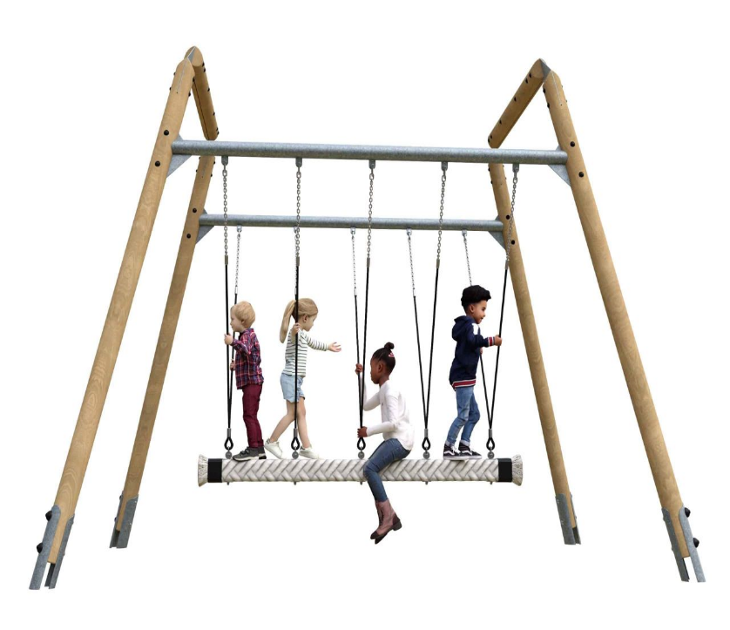

Location of Snake swing; between parallel bars and carousel (move chicken springer next to frog)

- Tipi carousel spinner from Komplan £2,116 including delivery plus VAT (20% discount was secured).

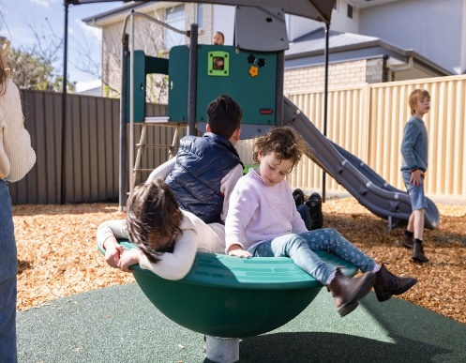

Located between Logworld and carousel
- Next, we will endeavor to implement a basket swing (also from an inclusive range) which will replace x2 baby swings.

- We are in the process of getting quotes for a gatehouse (wooden den).

- We will be seeking a quote, for the September meeting from Graham Hill to carry out;

- groundworks for snake swing level area
- install snake swing
- turf and safety surface rubber mats
- install gravity bowl in chosen position and safety surface rubber mats
- remove the chicken springer and store

- Other repair works to seal gaps between rubber mats under swings. We are planning to use a volunteer working party to clear debris and apply rubber filler. Materials about £500.

